**Software Requirements Specification (SRS) for File Converter Website**

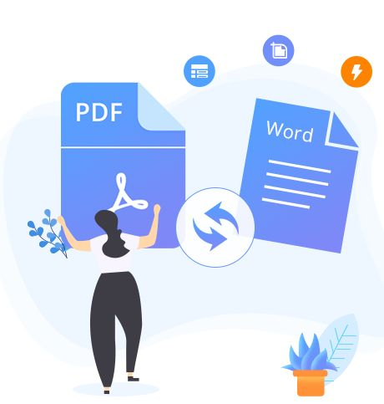

**Project name - Word to Pdf file converter Website**

**Table of content**

|  |
| --- |
| 1.Introduction |
| * Purpose |
| * Scope |
| * Glossary |
| 2. System Overview |
| 3.Requirement Analysis |
| * Functional Requirements |
| * Non-Functional Requirements |
| * Software Requirements |
| 4.System Design |
| * Use Case Diagram |
| 5.Database Design |
| * Class Diagram |
| * ER Diagram |
| 6.Future Scope |
| 7.Timeframe and Description |
| 8.Contribution Description |
| 9.Wireframe |
| 10.Conclusion |
|  |
|  |
|  |

**1. Introduction**

**1.1 Purpose**

The purpose of this document is to define the requirements and specifications for a web-based file converter application. The application will enable users to convert Word files (.docx) to PDF files and vice versa. The primary objective is to provide a secure, user-friendly, and efficient platform for file conversion.

**1.2 Scope**

This application will allow users to upload Word or PDF files and convert them into the desired format. The system will support:

* File upload and download.
* Frontend development using HTML and CSS.
* Backend functionality implemented in JavaScript.

**1.3 Glossary**

* File Conversion: The process of changing a file from one format to another.
* Frontend: The user interface and client-side components of the application.
* Backend: The server-side functionality responsible for processing file conversions.
* PDF: Portable Document Format.
* Word File: Microsoft Word document file (.docx).

**2. System Overview**

The file converter website will consist of a frontend for user interaction and a backend for processing file conversions. Users will upload a file, select the desired output format, and automatically download the converted file.

**3. Requirement Analysis**

**3.1 Functional Requirements**

* The system should allow users to upload Word or PDF files.
* The system should convert Word files to PDF and vice versa.
* The system should display error messages for unsupported file types or size limits.

**3.2 Non-Functional Requirements**

* The system should provide a responsive user interface.
* The system should process conversions within 5 seconds.

**3.3 Software Requirements**

* + Frontend: HTML, CSS
* Backend: JavaScript (Node.js or similar runtime)
* Frameworks/Libraries: None required (optional enhancements can include Express.js).

**4. System Design**

**4.1 Use Case Diagram**

A diagram depicting the interaction between the user and the system, highlighting file upload, format selection, conversion, and download.

User

upload word

Or pdf file

convert to pdf or word

download pdf

Or word file

System administrator

manage

system

setting

**5. Database Design**

**5.1 Class Diagram:**

Represents the classes for handling file uploads, conversions, and downloads.

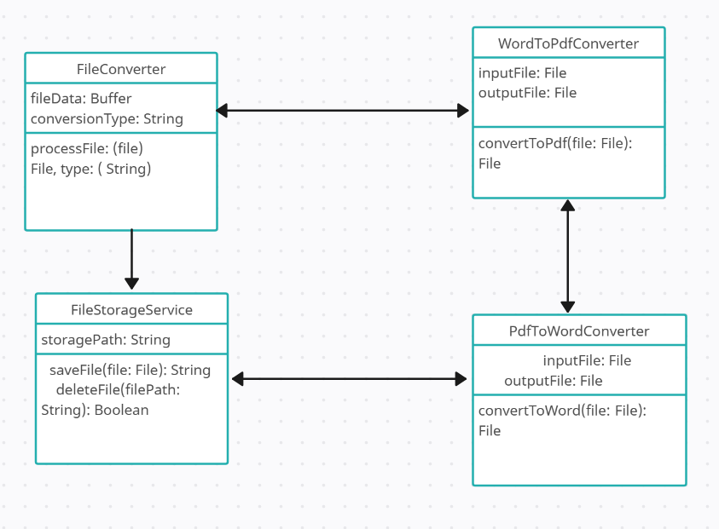

**6.Future Scope**

**6.1Enhancements**

1. Adding template customization options.
2. Supporting bulk file conversions.
3. Deploying the application on a cloud platform for scalability.

**7.Timeframe and Description**

1. Initial development: 2 weeks.
2. Testing and debugging: 1 week.
3. Deployment: 1 week.

**8.Contribution Description**

1. Frontend: HTML and CSS development – Ruchika jha
2. Backend: JavaScript implementation for file conversion – Shreya Gupta

**9.Wireframe**

A visual representation of the user interface, including file upload fields, conversion options, and download buttons.

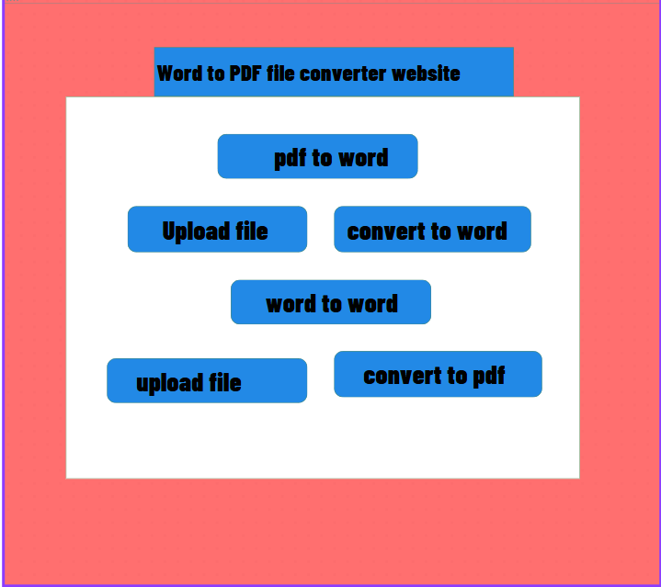.

**10. Conclusion**

The file converter website will provide a simple and efficient platform for users to convert files between Word and PDF formats. With its secure and user-friendly design, the application aims to meet user expectations and ensure reliable performance.